This tool is to demonstrate how to use OGCOCC.dll.

The demo tool is developed on Borland C++.

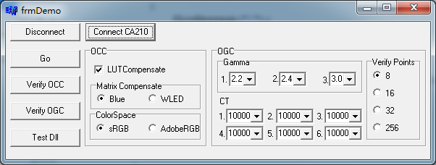

**8.**

**7.**

**2.**

**6.**

**5.**

**4.**

**3.**

**1.**

**[CA-210]**

1. Disconnect with CA-210;
2. Connect With CA-210(though USB cable)

**[OGC & OCC Setting]**

1. Go: do OCC & OGC calibration,
   1. OCC: including sRGB & AdobeRGB; User can refer to it for calibration flow details.
   2. OGC:3 Gamma, 6 Color Temperature.
2. Verify OCC: do verification (must calibrate first). The result will be indicated in the end; User can refer to it for verification flow details.
3. Verify OGC: do verification (must calibrate first). The result will be indicated in the end; User can refer to it for verification flow details.
4. Test Dll: in this button’s click function, you will find the basic ways to use the functions in dll. It needs no communication with IC or CA210.
5. OCC Defines:
   1. LUT Compensate: please always check it. It’s for low stage LUT compensate.
   2. Matrix Compensate: Blue is for Brianna IC, and WLED is for WLED Panel.
   3. Color Space: determine the final show of color domain.
6. OGC Defines:
   1. Gamma: User can set 3 groups of gammas, from 1.0 to 3.0 in 0.1 step;
   2. CT(Color Temperature): User can set 6 groups of Color temperatures, from 5000k to 10000K in 100K step.
   3. Verify points: Check points number in verification besides 255. For example, 8 points means gray pattern in digital code 0, 32, 64, 96, 128, 160, 192, 224 and 255 will be used in verification.